Crivitz Fall Harvest Fest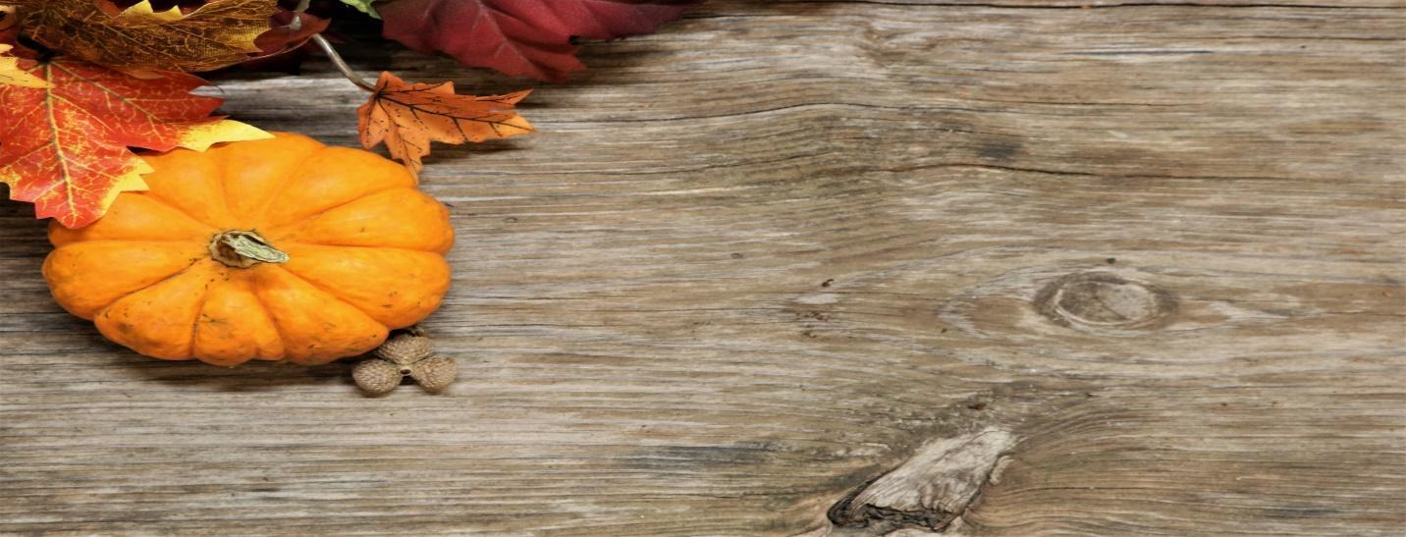

Craft Show

**September 27th, 2025**

**Hosted by Community Ed / Crivitz Youth Football**

**9 am to 2 pm**

**At Crivitz High School**

**400 South Ave, Crivitz WI 54114**

* **10’x10’ areas: Bring your own tables**
* **Set up booths from 6:30-9am**
* **Please no early breakdowns**
* **ALL CRAFTS/VENDORS WELCOME**

Please fill out the form below and return it along with a **$40 fee by September 15th** to:

Crivitz Elementary School, ℅ Julie Patefield, 718 Hall Hay St., Crivitz, WI 54114

If postmarked by September 15th, you will receive the same booth location as last year (if possible: FCFS). We will accommodate any new crafters the best we can on your location. If you want electricity, it is an extra $5. This request is accepted until September 8th. We cannot promise after this date. ***No refunds***. There is limited space, so we will fit as many in the gym, the auditeria, the hallway and outside grounds if needed. **If sending a check**, please make it out to **CRIVITZ SCHOOL (in memo: CE fall craft show).** We will advertise through local newspapers, flyers, and social media. You will be able to share those to your friends/family (or to your local buy and sell groups on fb) which will be posted on the Crivitz School Facebook page. If postmarked by Sept 15th, I will email you your booth #(s) by Sept 22nd (or via phone if no email). If postmarked *after* Sept 15th, you will receive your booth # the day of the show and we cannot guarantee your spot from the previous year [FCFS].

If you have any questions, contact Julie Patefield: jpatefield@crivitz.k12.wi.us, 715-854-2721 ext. 385

**PLEASE REMEMBER:**

1. **All items/crafts/vendors are accepted, not juried (this is changed from years past)**
2. **After unloading, move your vehicle to the other side of the parking lot until after the show. We must leave parking for customers!**
3. **After your booth is set up, please remove the tape from the floor**
4. **No carry-ins (unless medically necessary). The Host is selling concessions to raise money for their group. Thank you for supporting our efforts.**
5. **Clean up around your area. Do not leave garbage/boxes behind. Place near garbage cans or give to custodial staff.**

**I hereby release the School District of Crivitz and its employees, etc., from any liability which may arise in connection with my participation in this event including that through my own negligence. I furthermore accept responsibility for any injury or damage which may occur to anyone or anything as a result of my participation. I understand that the show hours are from 9am-2pm and that I may not break down early. Set up begins at 6:30am. Each booth space is 10’x10’ and tables are NOT provided. *NO REFUNDS***

*Make checks payable to: Crivitz School and indicate CE fall craft show on the memo line*

*Fee $40 (per booth) - if need electricity it’s an additional $5*

Electricity (circle if yes, +$5) Booths Total:__________ Check #__________ Total enclosed:___________

Name: Email:

Address:

Phone #:________________________ Seller Permit #____________________ or

last 4 of SS#________________

Brief description of items sold:

______________________________________________________________________________________________